Problem Set 1 Discussion

Callie Moody and Xiao Li

1/24/2021

Static region finding

To begin, choose a target color and then begin searching every pixel in the image to find the first one that matches the color.

Make a queue of points to be checked. Add the first point.

Create a new region containing that first point, and mark point as already added.

Check every neighbor of that point, and if they match the target color, add them as well.

Then, add each neighbor to the queue of points to be checked, marking them as part of a region.

Remove the center point from the queue.

Repeat the search for the neighbors and adding and removing from the cue

When the queue is empty, add the completed region to a comprehensive list of regions

Go back to the first line and continue searching for pixels that match and are not already part of a region, until every pixel has been checked

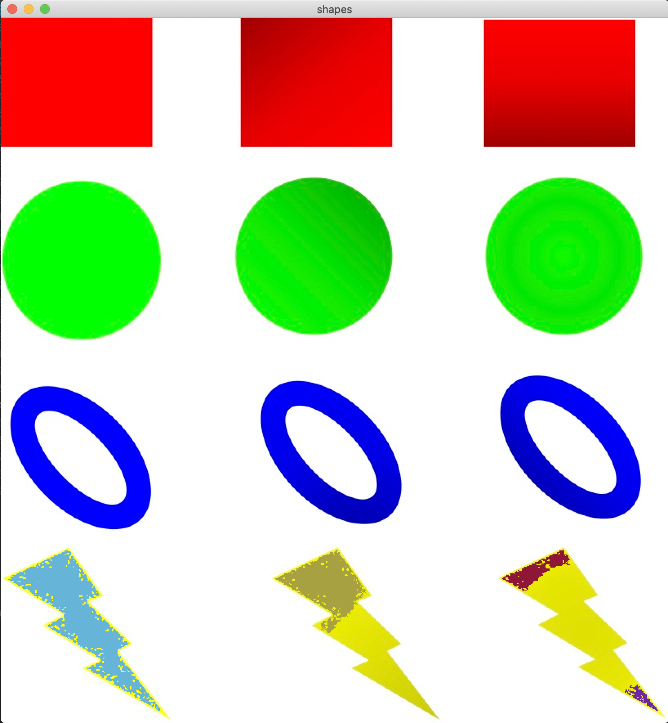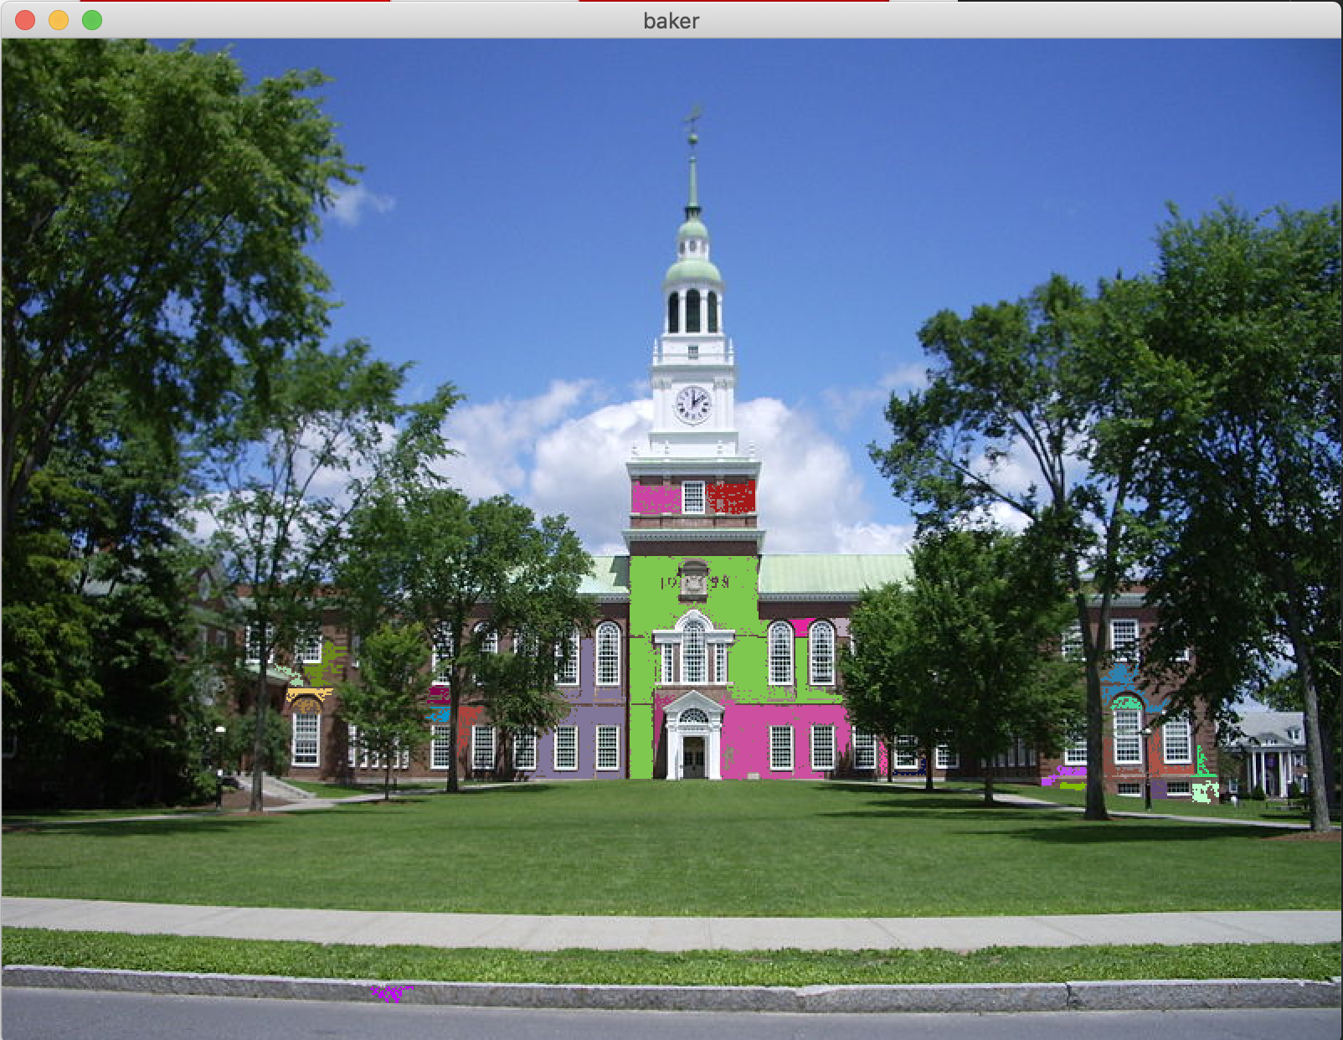

Streamed region finding

Use the same method as above, but reset the found regions for every new frame.

Through the webcam, lighting changes quite a bit causing object RGB values to shift. The computer doesn’t then recognize the object to be the same exact color, so the region finding can become a bit less exact, but the code is the same, as we use the same method for both.

